**Plugging Into The Future: An Exploration Of Electricity Consumption Patterns**

INTRODUTION

India is the world's third-largest producer and third-largest consumer of electricity. The national electric grid in India has an installed capacity of 370.106 GW as of 31 March 2020. Renewable power plants, which also include large hydroelectric plants, constitute 35.86% of India's total installed capacity. During the fiscal year (FY) 2019–20, the total electricity generation in the country was 1,598 TWh, of which 1,383.5 TWh generated by utilities. The gross electricity consumption per capita in FY2019 was 1,208 kWh.

In 2015-16, electric energy consumption in agriculture was recorded as being the highest (17.89%) worldwide. The per capita electricity consumption is low compared to most other countries despite India having a low electricity tariff.

In light of the recent COVID-19 situation, when everyone has been under lockdown for the months of March to June the impacts of the lockdown on economic activities have been faced by every sector in a positive or a negative way. The dataset is exhaustive in its demonstration of energy consumption state wise.

Analysing Electricity Consumption in India from Jan 2019 till 5th December 2020. This dataset contains a record of Electricity consumption in each states of India, here we are going to analyse State wise , Region wise and Overall Electricity consumption in India.

The business requirements for analyzing analysis on electricity consumption in IndiaIdentify the current patterns of electricity consumption in different regions and sectors of India. This information can be used to identify areas where consumption is high and areas where it is low. Identify opportunities for improving energy efficiency and reducing consumption in different sectors and regions. This information can be used to develop policies and programs to promote energy efficiency. This information can be used by government agencies, electricity providers, and investors to develop policies and make investment decisions that promote sustainable energy development and consumption in India.

A literature survey is a method of researching existing literature and studies related to a specific topic.The topic of electricity consumption in India is a well-researched area, with many studies having been conducted to understand consumption patterns and trends, as well as the impact of government policies and investment opportunities.A study by (Kumar et al., 2020) analyzed the electricity consumption patterns in India and identified the major contributors to the consumption. The study found that the residential sector was the largest consumer of electricity, followed by the commercial and industrial sectors.Another study by (Jain and Rathi, 2019) analyzed the impact of government policies on electricity consumption in India. The study found that policies promoting energy efficiency and renewable energy development have had a positive impact on reducing electricity consumption in India.

**Social Impact**: By providing access to electricity, the analysis can help to improve the quality of life for people living in areas without access to electricity, including providing access to lighting, heating, and cooling, and powering essential services such as hospitals and schools..

**Business Model/Impact**: By understanding consumption patterns and trends, the analysis can help businesses identify market opportunities and develop strategies to meet the growing demand for electricity in India.

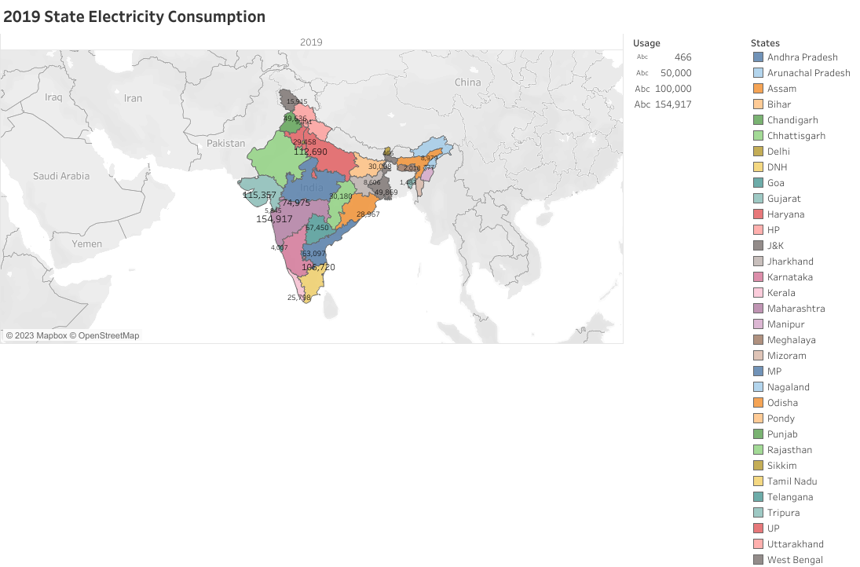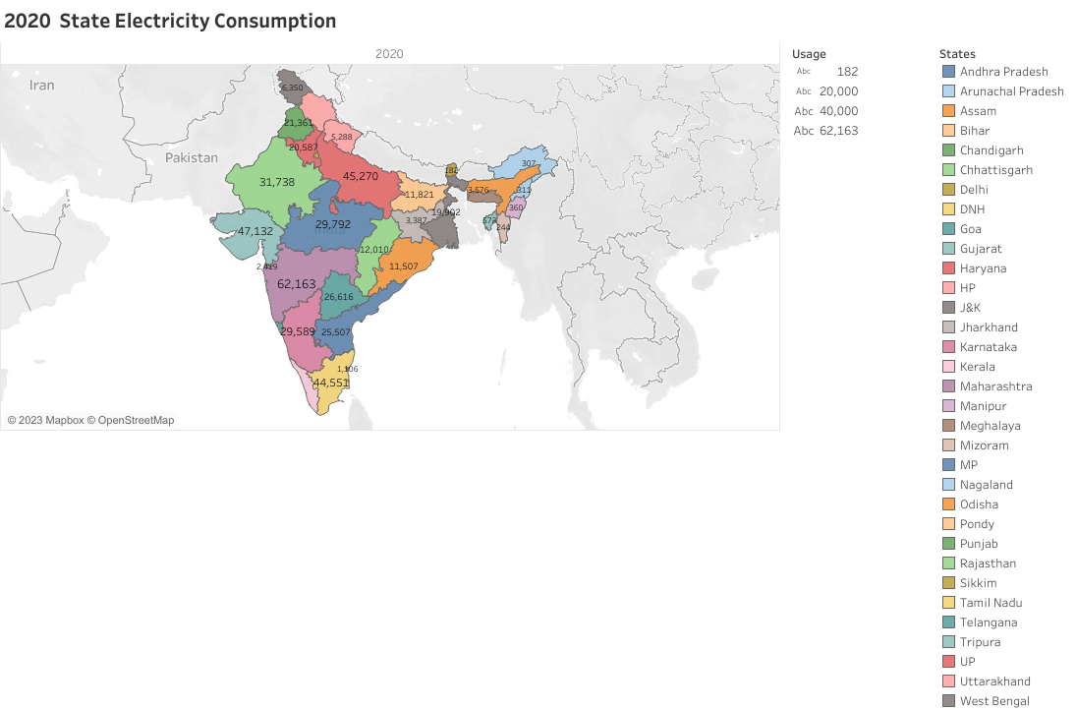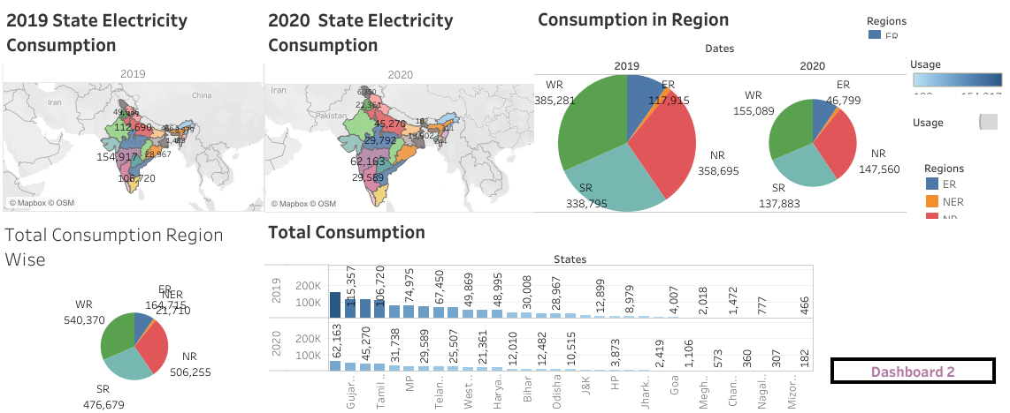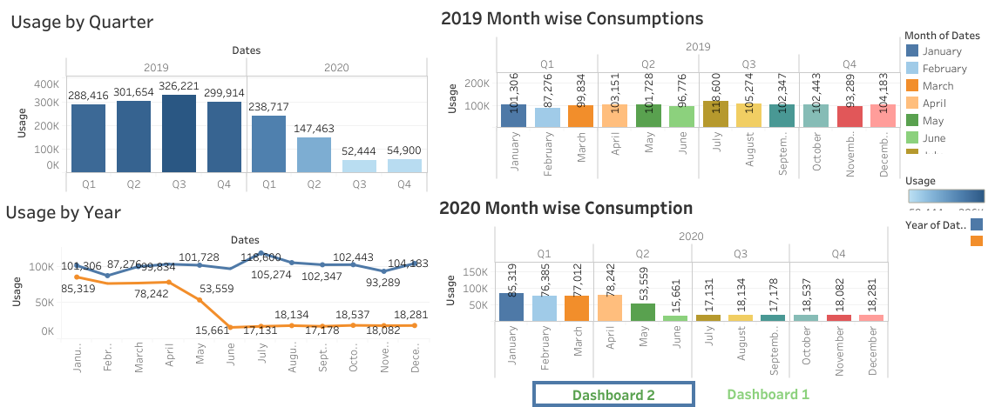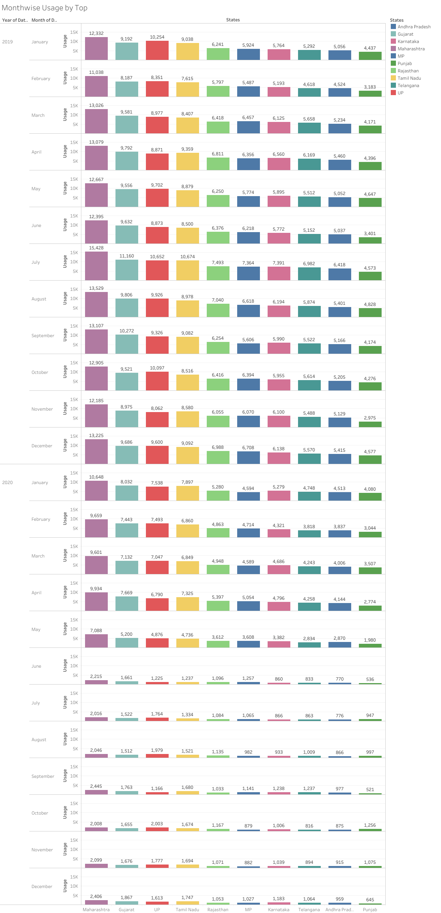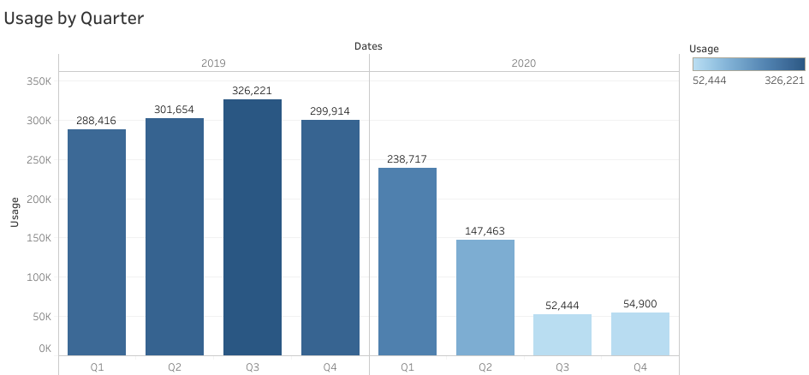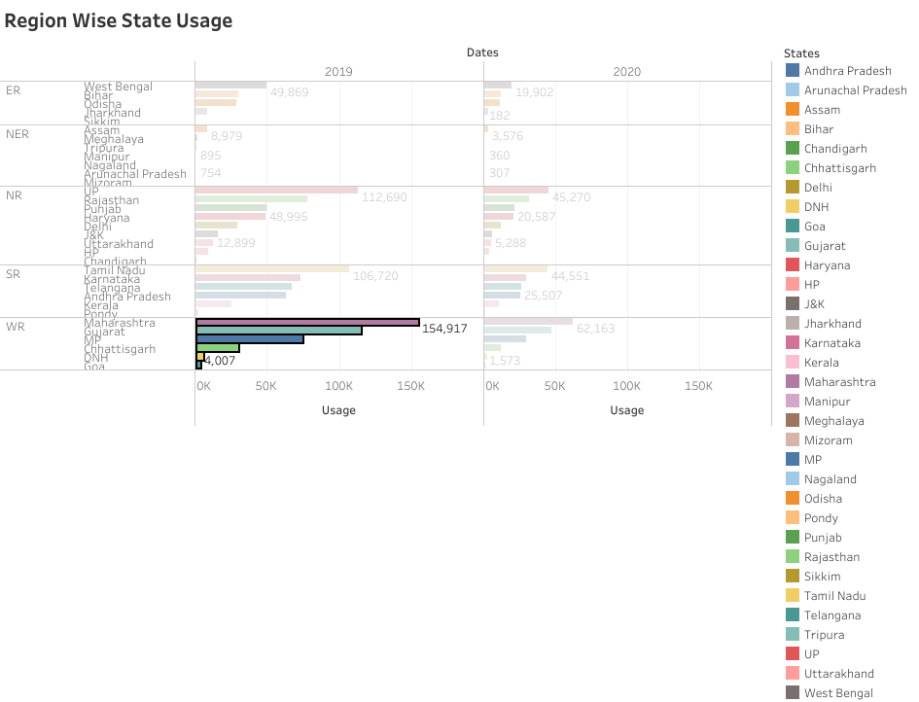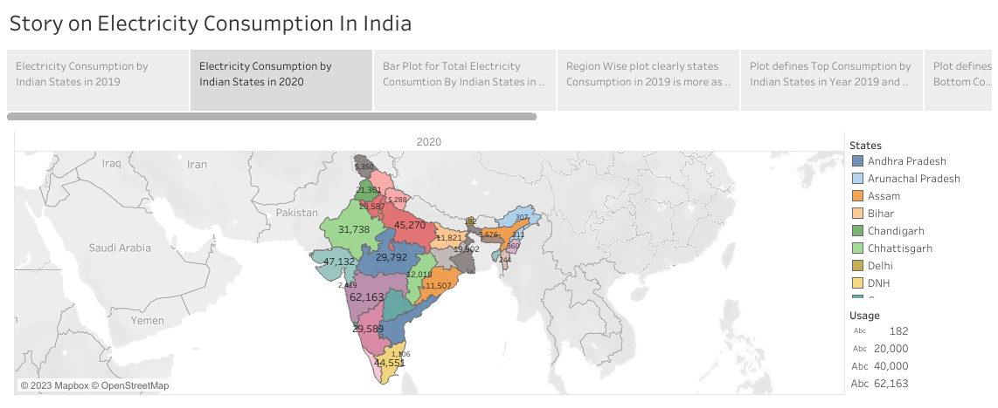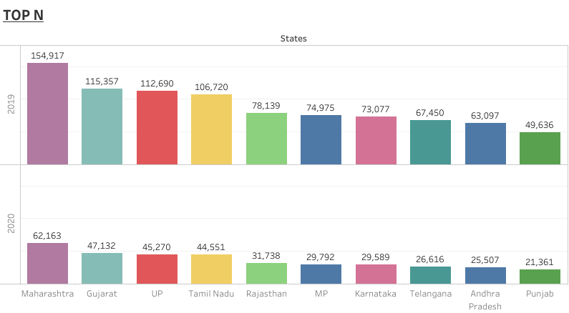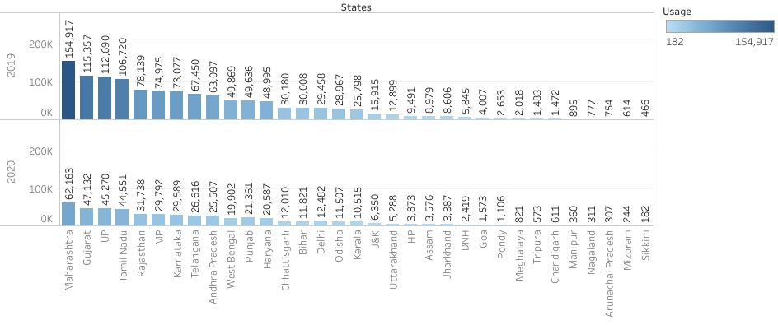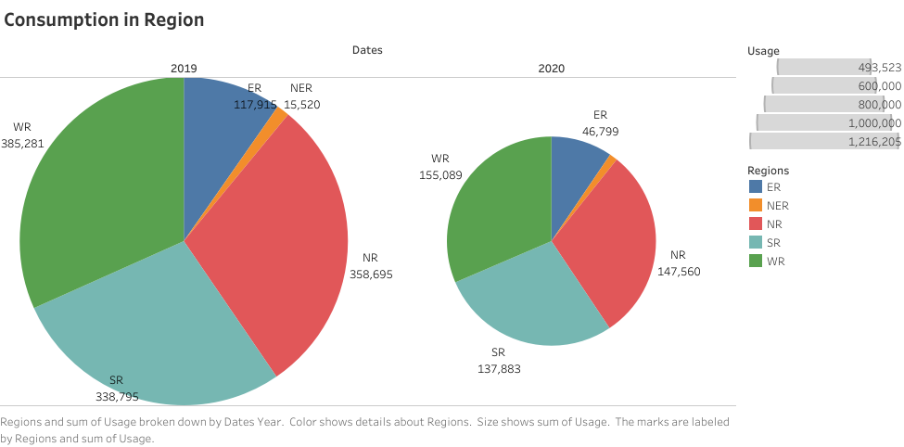

Data collect from:

<https://drive.google.com/file/d/1JxIkHNwXxjFztKq7ad0_KtkukCqTckNy/view?usp=sharing>

In Dataset Consumption.csv data is in the form of a time series for a period of 24 months beginning from 2nd Jan 2019 till 5th December 2020. Columns contains States, Regions, Latitude, Longitude, Dates andUsage. The dataset has been scraped from the weekly energy reports of POSOC.

Fields Include

                          States - Indian States

                          Regions- States in Regions on Indian Map

                          Latitude - States in Regions on Indian Map

                          Longitude - Geographical Coordinates of States

                          Dates - Dates of Usage

                          Usage - Power consumed in Mega Units(MU)

Conclusion

Maharashtra is the Highest Electricity consumption user of India.

Tamil Nadu is the Thrid Highest Electricity consumption user of India.

Sikkim is the Lowest Electricity Consumption user of India .

Electricity consumption was more in the year 2019 and 2020 in West Region.

 Electricity Consumption was less in the year 2019 and 2020 in northeasern.

 Electricity Consumption in 2019 for Quarter 1 was Lowest.

 Electricity Consumption in 2019 for Quarter 3 was Highest.

 Electricity Consumption in 2020 for Quarter 3 was Lowest.

* Electricity Consumption in 2020 for Quarter 1 was Highest.

Dashboard link:

<https://public.tableau.com/views/Elec_Dashboard210423/Dashboard1?:language=en-US&:display_count=n&:origin=viz_share_link>

Story link:

<https://public.tableau.com/views/Elec_Story210423/StoryonElectricityConsumptionInIndia?:language=en-US&:display_count=n&:origin=viz_share_link>

Videolink:

<https://drive.google.com/file/d/1zskMjjfOhCLLWOFzw5W2yiMZjL6nQh4M/view?usp=drivesdk>